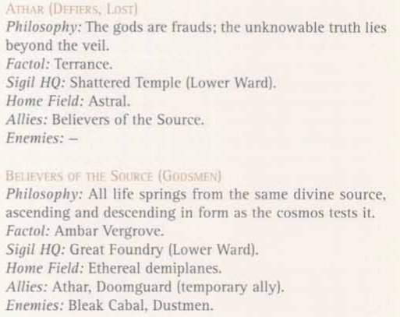
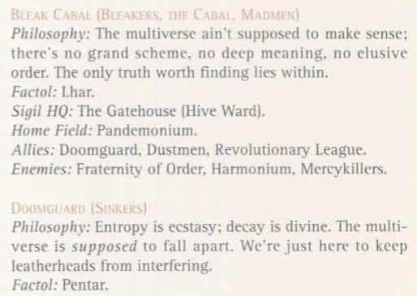
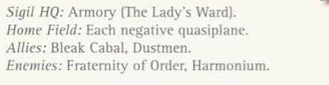
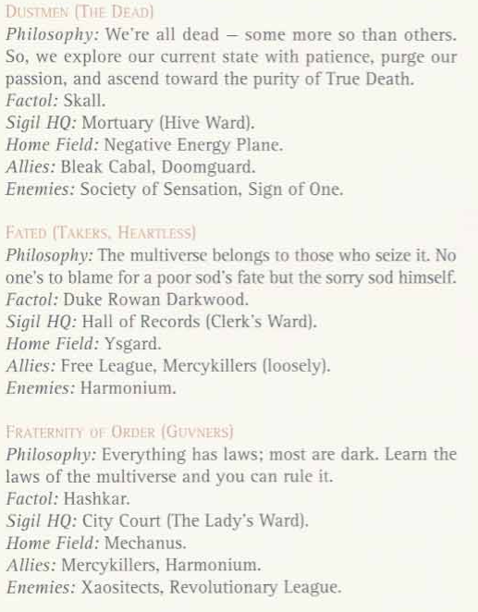
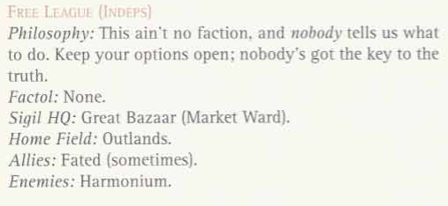
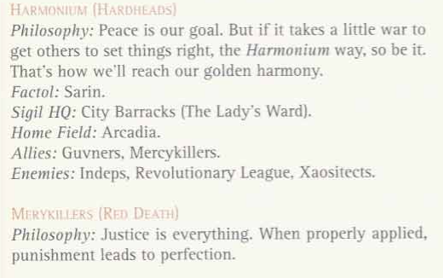
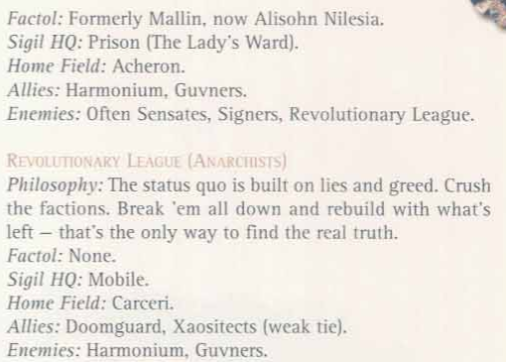
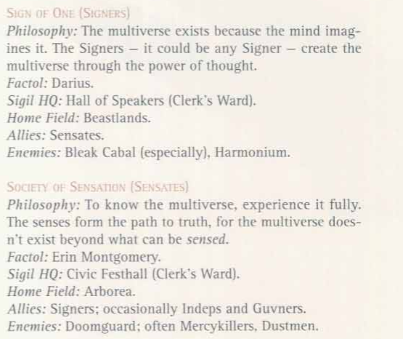
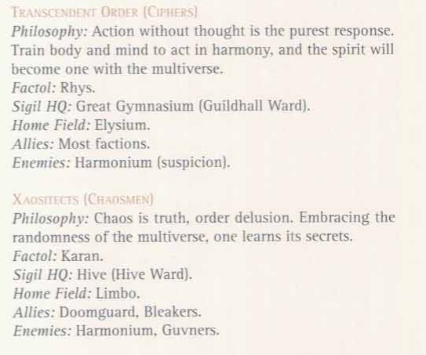

Fraternity of Order
"The planes are governed by laws. Laws can be learned. Learn the laws, and you rule the multiverse. That is our goal." -Factol Hashkar of the Fraternity of Order

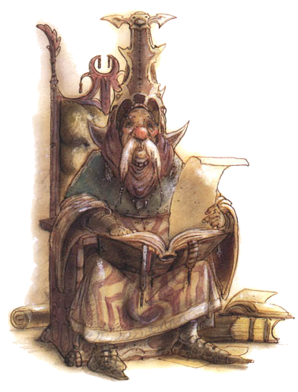
These folks are sure that everything’s got laws. Mankind’s got laws. Sigil’s got laws. Even the Elemental Chaos has got its laws. Now, once a body’s got the laws down, he does pretty well, right? He knows how to use them to his advantage, and how to break them without getting caught. If everything’s got laws, then there are laws for the whole birdcage -- the planes and all that. And if everything’s got laws, then those laws can be learned. See where this is going? Learn the laws of the planes and learn how to break ‘em, how to use ‘em to best advantage. Get to be a real blood, a pro, and a basher’d have real power.
Think of the things a body could do with the laws of the multiverse under his thumb. He could manipulate the very heart of things! It’d make magic seem like a lousy put-up, make a fellow who knew the dark of things a real high-up man. He could find the loopholes of the multiverse, the little spots not covered by any rules, where he could do what he wanted. He’d be tougher than the powers themselves!
‘Course, it ain’t that easy. The multiverse keeps its laws dark, where a body’s not likely to find them. More than a few cutters have got themselves put in the dead-book trying to learn it all. Then there’s the powers -- it ain’t likely they want any sod getting the secrets of more power than them.
So let all the other berks run around, looking for the meaning of the multiverse. It doesn’t matter what it all means, because that won’t tell a body how it all works. Knowing the operation of things -- that’s what’s important. Who cares what it means when a blood can make it do what he wants?
So how’s a fellow to find out? Knowledge -- knowledge is power. It takes study, it takes searching. Sometimes a body’s got to go out into the planes and look for the answers. Sometimes it takes science, study, and research. There are millions of laws to make this thing go, and the more a body knows, the more he can do.

Athar
"Hey, you berk! If the gods really were alive and cared, do you think you’d be here?" -Factol Terrance of the Athar

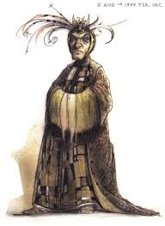

According to these folks, the great and feared powers are liars! Those who claim to be the ‘gods’ of the planes are just mortals like us. Yeah, they’re unbelievably powerful, but they’re not gods. After all, they can die, they’ve got to keep their followers happy, and they often feud among themselves like children. Bahamut, Kord, and the others -- they’re all imposters.
Sure, there might be a true god, or maybe even more than one, but such power is beyond all understanding. Such beings cannot be seen, spoken to, or understood by mortals. What’s the proof? Look at divine magic -- countless priests who’ve turned stag have proven that their magic doesn’t come from any power. Where do these abilities really come from? Why, it must be from the unknowable, from the true god that is behind everything, and the powers are nothing but channels for its will. Foolish mortals believe the powers are the source of all majesty, and why would the powers do anything to correct that mistake?
The astral domains are all lies, too. These planes aren’t the abodes of supreme beings, just lands shaped by the wills of the powers. Anyone could do it with enough expertise. All the sweat and worry of petitioners ain’t just for oneness with their plane - it’s for a greater reward, if there’s any at all. Proxies are merely magical or bio-magical transformations, the result of natural planar magic.
‘Course, the Athar ain’t stupid. “Let the powers call themselves gods,” they say. “It ain’t worth the laugh, because there’s no point upsetting the powers.” With all that might, an angry power’d be a dangerous enemy. All the Athar want is to part the veil, discover the secret behind everything, and look on the face of the unknowable.

Believers of the Source
"We are all one - gods, mortals, even demons come from the same source. Who knows? Maybe next time you’ll be a larva." -Factol Ambar Vergrove of the Believers of the Source

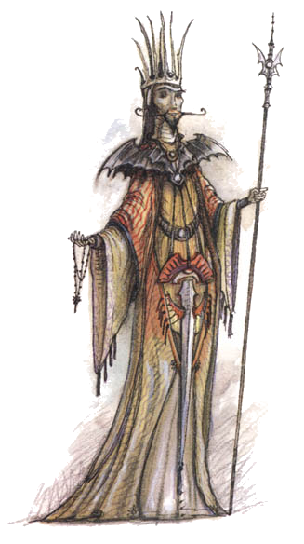

To these characters, all things are godly. All things can ascend to greater glory -- if not in this life, then in the next. Patience, that’s all it takes. See here’s the chant: Everything -- primes, planars, petitioners, proxies, the whole lot -- is being tested. Survive, succeed, and ascend -- that’s the goal of all beings. Fail and get reincarnated to try again. It’s pretty simple and straightforward.
‘Course, it ain’t that easy either. First off, nobody really knows what the tests are. Is a body supposed to be good, evil, or what? Godsmen are trying to figure that out. Second, a fellow just might go in reverse -- mess up and come back as a prime or something worse in the next life. It could even be that those who do really badly return as fiends. Finally, there’s one last step nobody even understands. Getting to be a power ain’t the end of the cycle. There’s something beyond that, something that powers, themselves, eventually ascend to. Cross that threshold to the ultimate form and get released from the multiverse forever.
Now, there’s a fixed number of beings out there, and sooner or later we’re going to run out, when everybody’s ascended. A lot of the worlds on the so-called ‘infinite’ Prime Material Plane are already pretty thinly populated. When a prime ascends to the next level, then there’s one less prime in all the multivers -- unless, of course, a planar somewhere fails and falls back a rank. But sooner or later, everybody’s going to attain the ultimate goal, the final ascension, and when that happens the multiverse ends -- closes up shop, fades right out of existence.
So you see, the Godsmen calculate that’s the whole purpose of the multiverse. The Prime Material, the Elemental Chaos, and the Atral Sea -- they exist to test and purge. It’s just a matter of figuring what’s being tested and how. When that happens, the Godsmen can hasten the end of the multiverse and get on with some new existence.

Bleak Cabal
"Hear the barmies howling in the mazes? If you’re here to learn the secrets of the multiverse, you might as well save yourself some time and go join ‘em. ‘Cause that’s all it means - that and nothing else." -Factol Lhar of the Bleak Cabal

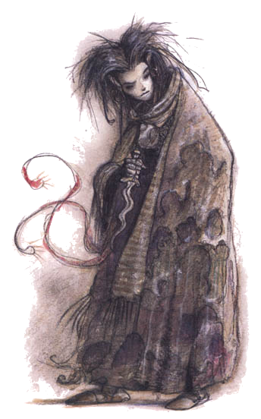

“There’s no meaning to it all,” say the members of this faction, “so just give it up, poor sod. Whoever said reality had to make sense?” To these folks the multiverse ain’t even a cruel joke, because that would give it all meaning. Look at all those fools in their factions, running around, trying to discover the meaning of something that’s senseless. They’ll waste their lives at it. And they call the Bleak Cabal mad -- hah! Here’s the Bleaker credo: “The multiverse doesn’t make sense, and it ain’t supposed to.” That’s all there is to it, pure and simple. It ain’t “The multiverse is without meaning,” because that answer’s a meaning in itself.
Look, the primes, the petitioners, proxies, even the powers don’t have The Answer.
Nobody is here for some higher purpose. Things just are, and whatever meaning there is in the multiverse is what each being imagines into the void. The sad part to the Cabal is that so many others refuse to see this. Looking for ‘the truth,’ these people don’t see it. Once a sod understands that it all means nothing, everything else starts to make sense. Thats why some folks go insane -- from hunting for the snipe that ain’t there. ‘Course, soem folks just can’t handle the truth. They’re the ones that howl and rage, gibber in the corners, and plead with the powers, as if that would help them. Well, too bad for them. Bleakers know the hard truth, and if other folks can’t deal with that, it’s no concern of theirs.
For someone to join the Cabal, he or she (or it) has got to do three things: quit looking for meanings, accept what happens, and look inward. There’s no meaning on the outside, so the question is, “Is there any meaning inside?”

Doomguard
"Everything decays, and we’ll be ready for the day when the last bit crumbles into nothing. Will you, berk?" -Factol Pentar of the ‘Guard

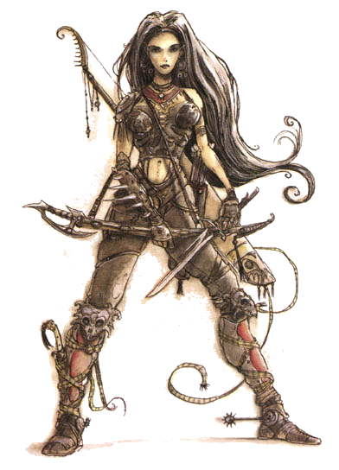

Ever hear of entropy, berk? Take a look around: Everything's going down the tubes, falling apart, stopping. People die, rocks erode, stars fade, planes melt away. That's entropy, the fate of the multiverse. A lot of folks think that's a terrible thing, but not the Doomguard. They're pretty sure nothing lasts forever, not even the planes. It's the way things are supposed to be, they guess, the goal of everything. Sooner or later, the last bits of the multiverse'll decay, and then there'll be nothing left - think of it as existence's ultimate release from toil and pain.
Now, the sods who try to fix things - stop the decay and put everything back together - they've got it all wrong. They're fighting the natural goal of the multiverse, trying to do something unnatural. That ain't right.
Don't get this faction wrong. It's not like somebody builds a house and they tear it down. That building's part of the whole decay: The stonecutter chips the rock, the logger cuts the tree, and later the termites chew the beams until the whole case comes down on its own. There's a long view to this. The sod who can't see the grand scheme'll go barmy trying to tear down everything that gets built.

Dustmen
"Die and let die." - Faction motto

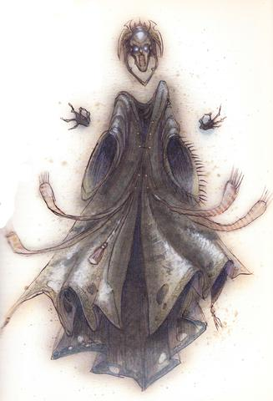

These guys say Life's a joke, a great trick. Nobody's alive; in fact, there's no such thing as Life. Sure, the petitioners are dead compared to the rest of us, but everybody else is dead too - they just don't know it yet. So what's the chant? Simple: "All these worlds and all these universes are just shadows of another existence." This multiverse - this is where beings wind up after they die.
Look, if things were truly alive, would there be such pain and misery in the multiverse? 'Course not! Life is supposed to be about celebration and positive feelings. Existence here is muted, dull, full of pain, and twisted with sorrow. What kind of celebration is that? This existence is a mockery of true life.
The berk who gets restless and rushes things dies a fool, and he'll probably be forced to go through the whole thing all over again - that's a real waste of time! Here's the chant: Respect Death, and don't ever treat it like a servant.

Fated
"I wasn’t born a factol, or even a duke like most berks think. I earned what I’ve got today, and you can do the same." -Factol Duke Rowan Darkwood of the Fated

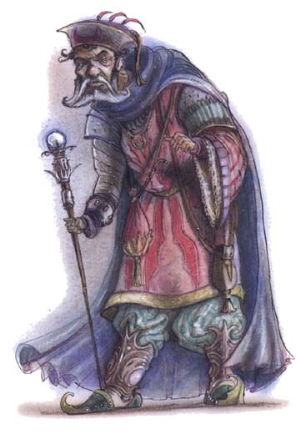

This faction says the universe belongs to those who can hold it. Each sod makes his own fate, and there's no one else to blame for it. Those who whine about their luck are just weaklings; if they were meant to succeed, they could have. Here's the way the multiverse works, according to the Takers: Everybody's got the potential to be great, but that don't mean it's going to happen. Those that work hard get what they deserve.
There's no point feeling sorry for the berks who didn't make good - it was their own fault for being weak. Some softhearted folks call this a cruel philosophy. Well, that's just an excuse for weakness. Sure, there's compassion, but a body's still got to earn it.
Most folks think there's nothing to the Fated but taking, but the Takers'll tell a berk there's a lot more than that. There's lots of things a being has to earn - respect, for instance. That's something the Fated believe can't be taken by force.

Free League
"Only the strong believe in themselves." - Bria Tomay of the Free League

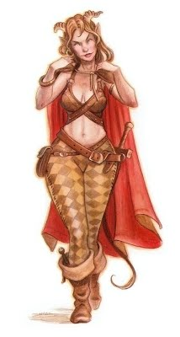

This ain't no faction and nobody tells them what to do. The idea that any berk knows the truth and everybody else's wrong - well, that's a chance a body shouldn't take. Who's right - the Guvners? The Mercykillers? The Chaosmen? Since when does a smart gambler play all his jink on a single throw?
Still, a body's got to belong to something if he wants to stay alive. The Free League's kind of an informal group of like-thinkers. They share news, pass around jobs, and watch each other's backs. Hey, in a place like the planes, a body can't be too careful.
Some figure Indeps to be cowards, afraid to play a stake on the truth, but Indeps see themselves as free thinkers, refusing to be shackled to some blind ideology. Truth is, there are some that don't want to make the choice, for fear of offending one power or another. Then again, there's plenty of folks seeking to make their own truth - maybe even start themselves a new faction.

Harmonium
"Do it our way, or no way. Understand that, berk?" -Factol Sarin of the Harmonium

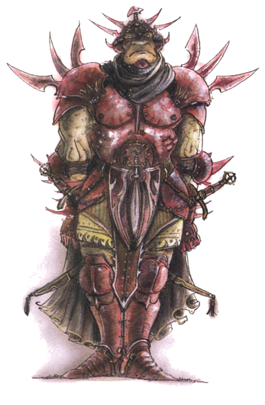

The secret of the multiverse? That’s simple, and every cutter in the Harmonium knows what it is: “The Harmonium is always right.” Look, the goal of every enlightened being in the multiverse is to live in perfect harmony with all others. Look around: Peace or war -- those are the only true states of the multiverse. If a being and its neighbors got the same views, then there’s peace between them. When they don’t agree, that’s what causes war; one body figures it can use fists to convince the other. Now, there’s some powers who say otherwise, but the Harmonium believes that peace is a better end than war. For one, all of a body’s work won’t get destroyed during times of peace. Families don’t get killed, kings can actually spend time ruling the people, scholars can study, and petitioners can raise their crops. Everybody, even the demons in the Abyss, can prosper.
On the other hand, the Harmonium says there’s only one way to have peace: their way. War or peace -- squabble among each other or join the Harmonium -- those are the only choices. The Harmonium believes that the ultimate goal of the multiverse is universal harmony, and it’s ready to spread that belief to all those other sods out on the planes. If it takes thumping heads to spread the truth, well, the Harmonium’s ready to thump heads. Sure, there may not be peace right away, but every time the Harmonium gets rid of an enemy, the multiverse is that much closer to the universal harmony it was meant to have.
And what happens once the Harmonium succeeds? (And it will succeed, that’s certain -- just ask them.) That part’s simple. When everyone is in agreement with the Harmonium, a new golden age will begin. That’s why the Harmonium works so hard to get folks to conform -- it’s all for their own good.

Mercykillers
"Justice is right, justice is sweet, and justice purifies all. We are justice." -Factol Alisohn Nilesia of the Mercykillers

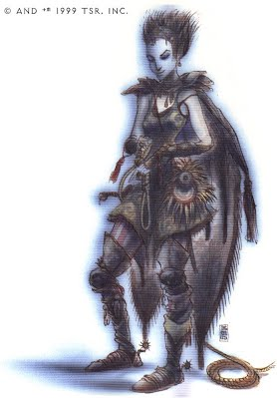

As far as this faction’s concerned, justice is everything, and there ain’t no sod who can give it the laugh. Those cutters that try’ll have the Mercykillers on their tail, so the smart thing is just don’t try. It’s the whole reason laws exist -- to see that justice is carried out. Justice purges the evil in folks and makes them better, fit to belong in the multiverse. Once everybody’s been cleansed, then the multiverse reaches perfection, and perfection’s the goal of the multiverse. Justice is absolute and perfect, but it’s got to be correctly applied. A body’s got to know the knights of the post, the criminals from the innocent, so he doesn’t make a mistake. Mercy’s an excuse created by the weak and criminal. They think they can rob or kill and then escape their crimes by pleading for mercy. The Mercykillers are not so weak. Every crime must be punished according to the law. There are no such things as ‘extenuating circumstances.’
That being the case, some smart cutters figure they’ll hang the Mercykillers by their own yardarm and accuse them of some of their own crimes. Well, the Red Death’ll just smile and say it answers to a higher law. Charged with protecting justice, they can do things others can’t -- all in the name of justice. How else could they survive their own ideals?
‘Course now, other folks don’t agree with Red Death logic. To them, the Mercykillers ain’t above the laws or even right in what they do. The Mercykillers don’t like such folks’ attitudes, but they can’t hand a being for its opinions -- at least not in most places. See, the Mercykillers say they don’t make the laws, they only enforce them. All in all, they’re no better than the rest, but no worse than a few.

Revolutionary League
"We have no past, and you have no future." - One of many faction mottos

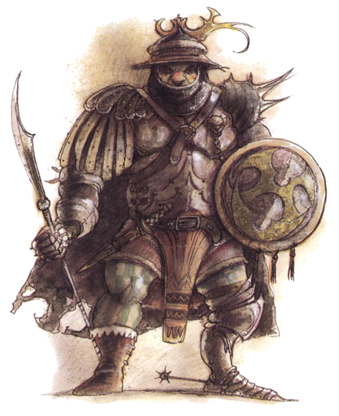

"These universes, these powers, they're all corrupt!" screams this faction. "They're guiding people in the wrong directions, keeping them as slaves and prisoners to the powerful. The old beliefs are lies." These sods claim that the Guvners, Chaosmen, Mercykillers, Athar - every last one of them - no longer care about the truth. Their factols have all the property, bodyguards, jink, and influence. They're not looking for the truth; they just want to hang on to what they've got.
Well, the Anarchists say it's time for that to change. It's time to break free of the chains and seek the real truth. And that's only going to happen when a body's free of the bonds of the other factions. A being's got to be able to make his own choices, but would any faction just let a body go? Think the Harmonium would say, "Sure, we admit we're wrong. Go find your own way." Not a chance!
Once the factions come down, then folks can find the real truth. Break it all and rebuild with the pieces that are left - that's the only plan.

Sign of One
"Where’s the center of the multiverse? Me - I’m the center of the multiverse." -Factol Darius of the Sign of One

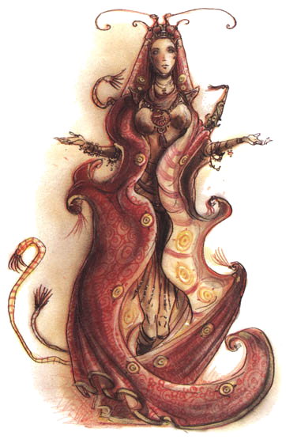

Every person, every individual, is unique. This is the greatest glory of the multiverse -- that each creature living (and dead) is different from all others. It’s obvious, then, that the multiverse centers around the self, or so this faction would have everyone believe. “It’s quite simple, addle-cove,” one of these sods would say. “The world exists because the mind imagines it. Without the self, the multiverse ceases to be.” Therefore, each Signer is the most important person in the multiverse. Without at least one Signer to imagine it all, the rest of the factions would cease to exist.
Better be nice to the Signers the, berk, because they just might decided to imagine a body right out of existence. Don’t think it can be done? Maybe not, but then a basher’s a fool to take the risk. Lots of folks disappear without a trace, and more than a few are enemies of the Signers. Makes a body think, don’t it?
So, some smart cutter’ll say, what happens if two Signers don’t agree? What if they both think different things? Then what happens? After all, the multiverse is the same for everybody. The answer’s easy for a Signer. Since he’s the center of the multiverse, then obviously everything else is from his imagination -- simple. Nobody else really exists except as he thinks of them, so of course the multiverse is the same. How else could it be?
A lot of folks don’t accept this idea. After all, they point to their own feelings and emotions, their own self, as proof the Signers are wrong. And the Signers simply claim to have imagined it all. What others feel and think isn’t real; only what the Signers feel is.
So exactly who is imagining the multiverse? That part even the Signers don’t know for sure. One of them is, but they can’t agree on which one. The safest bet is just to fall in with their faction, because any Signer could be the source of everything. Remember that, berk.

Society of Sensation
"Touch it. Smell it. Taste it. See it. Hit it." -Factol Erin Montgomery of the Society of Sensation

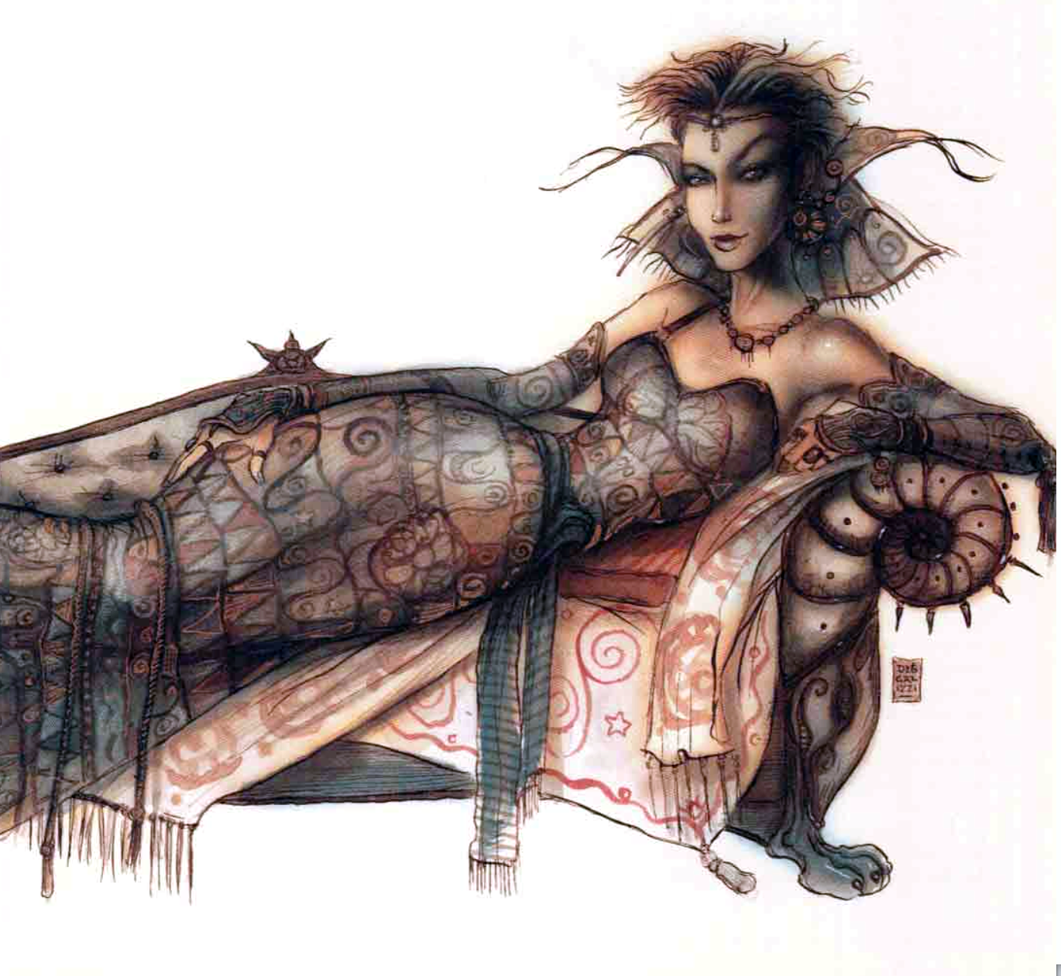

According to these folks, the multiverse is known by the senses -- the only proofs of existence. Without experience, without sensation, a thing isn’t. If a sod can’t taste the soup, then it ain’t soup. The only way to know anything for sure is to use the senses.
Look, it ain’t that hard to understand. Which is real, a description of a rose or the rose itself? Only a barmy’d choose the description, which ain’t real. It’s got no smell, no thorns, no color. Picking a rose, that’s real, and the way a body knows is by experiencing it. The senses are the only way to know the multiverse.
So some berk’ll ask, “What’s this got to do with universal Truth, the meaning of the multiverse?” Well, the chant is no one’s going to know the big dark until they’ve experienced everything -- all the flavors, colors, scents, and textures of all the worlds. Only when a body’s experienced the whole multiverse does the great dark of it all finally get revealed. It may seem like an impossible task, but there just might be a way to bob the problem -- cheat the multiverse, as it were. It just might be that the multiverse doesn’t exist beyond what a body can sense. The answer to what’s over the next hill just might be ‘nothing.’
Given that, the multiverse has limits, and a body can try to experience it all. A being’s got to savor the intensity, explore the complexity. Don’t just guzzle the wine -- find all the flavors within it. Before a sod’s all done, he’ll learn the differences between Feywild and Astral wine, know them by vintage, and even by the hand of the vintner. Only then do the secrets of the multiverse start to make themselves clear.

Transcendent Order
"By the time you’ve thought about it, I’ll have killed you. That makes it a do-or-die deal." -Factol Rhys of the Transcendent Order

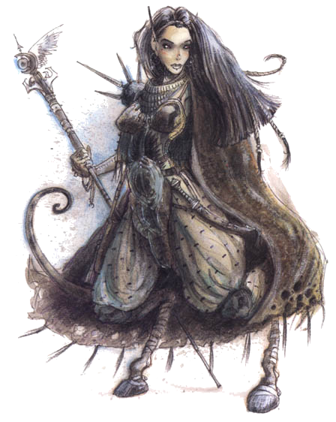

These guys say that for a body to become one with the multiverse, he’s got to stop thinking and act. Action without thought is the purest form of thought. When a cutter can know what to do without even thinking about it, then he’s become one with the multiverse.
It goes like this. Every berk’s part of the multiverse, and nothing’s apart from it. So it figures that every being knows the right action to take at just the right moment. Problem is, some folks start thinking and mess it all up. Thinking adds hesitation and doubt. It overrules instinct and separates a sod from the multiverse. By the time a poor sod’s thought about something, the right action for the right moment is gone.
So all a berk’s got to do is just quit thinking, right? ‘Course it ain’t that easy. Any addlecove can blunder in and act without giving it a thought, but that’s not the goal. A body’s got to work hard at learning himself -- learning his own mind and instincts until the right action comes automatically. It’s done by training both the body and mind. Just like the way thieves practice their cross-trade, a Cipher’s got to train his mind (the source of action) and body (the actor) to be one thing. There’s no difference between the two, no separation between thought and motion. Body and mind act as one -- the hand moves before the thought reaches it.
So what’s all this get a fellow, then? Once mind and body are in harmony, the spirit becomes in tune with the multiverse. A blood understands the purpose of the multiverse and knows just where and how he should be.

Xaositect
"Beautiful is! Chaos too dim multiverse is too notice most the of." - Factol Karan of the Xaositects

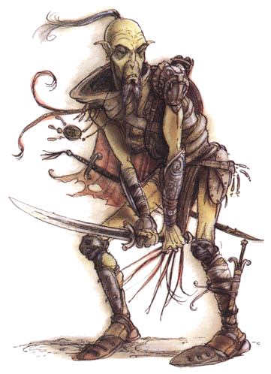

As these sods see it, the multiverse wasn't born from Chaos - the multiverse is Chaos. There's no order, no pattern to anything. That's the meaning of the multiverse, the great secret everyone else is just too dull-witted and cowardly to admit! Look around. Is there any pattern to this existence? Any order that gives it all meaning? None, not a one.
So why fight it, since Chaos is how things are meant to be? It has a beauty and wonder all its own. By gazing upon Chaos, learning to appreciate the randomness of it and understanding its sublime intricacies, the Xaositects learn the secrets of the multiverse. They want to play within the unshapeable Chaos, and to be a part of its uncontrollable energies.

Athar
Allies: Believers of the Source
Enemies: --
Believers of the Source
Allies: Athar, Doomguard (Conflicted or Negative only)
Enemies: Bleak Cabal, Dustmen
Bleak Cabal
Allies: Doomguard, Dustmen, Revolutionary League
Enemies: Fraternity of Order, Harmonium, Mercykillers
Doomguard
Allies: Bleak Cabal, Dustmen
Enemies: Fraternity of Order, Harmonium
Dustmen
Allies: Bleak Cabal, Doomguard
Enemies: Society of Sensation, Sign of One
Fated
Allies: Free League, Mercykillers (Negative only)
Enemies: Harmonium
Fraternity of Order
Allies: Harmonium, Mercykillers
Enemies: Revolutionary League, Xaositects
Free League
Allies: Fated (Conflicted or Negative only)
Enemies: Harmonium
Harmonium
Allies: Fraternity of Order, Mercykillers
Enemies: Free League, Revolutionary League, Xaositects
Mercykillers
Allies: Fraternity of Order, Harmonium
Enemies: Revolutionary League, Sign of One, Society of Sensation (Positive or Conflicted only)
Revolutionary League
Allies: Doomguard, Xaositects (Negative only)
Enemies: Fraternity of Order, Harmonium
Sign of One
Allies: Society of Sensation
Enemies: Bleak Cabal (Negative only), Harmonium
Society of Sensation
Allies: Fraternity of Order (Conflicted or Negative only), Free League (Conflicted or Negative only), Sign of One
Enemies: Doomguard, Dustmen, Mercykillers (Positive or Conflicted only)
Transcendent Order
Allies: Any except Harmonium (Conflicted only)
Enemies: Harmonium (Positive or Conflicted only)
Xaositects
Allies: Bleak Cabal, Doomguard
Enemies: Fraternity of Order, Harmonium

Icon Relationship Master Chart
Faction  Type | Positive  Relationship | Conflicted  Relationship | Negative  Relationship
Allies | As far as this faction is concerned, your actions further their cause. You share guildhall privileges with members and may be able to call on favors from faction higher ups.  You might also be a target to the faction's enemies. | You have the potential to be a friend to the faction, but for some reason you're suspect. Maybe you've had a change of heart in the past, or acted against the interests of the faction.You have some insider knowledge and friends in the organization, but enemies as well. | You are a dissident, upstart, rival, or outright foe. Although you have contacts within the faction, few would be seen with you and you can expect trouble wherever the faction has influence.
Ambiguous | Some within the faction consider you a useful contact, others a negative influence or even a saboteur. The enemies of your friends may turn out to be your friends, and vice versa. Advantages and complications will come from all sides. | Your relationship to the faction is complex, perhaps hard to explain to superiors, and for every help you enjoy, there will certainly be a consequence somewhere down the line. | Your enmity with this faction makes you some enemies, but it also makes you some useful friends. You may be a dissenter, distant relation, or even a traitor in some way.
Enemies | You can scrounge secrets or clandestine allies, but your connection to this faction brings trouble from your own ranks. | You mostly work against the faction, but have some small connection you can't deny. That connection sometimes gives you special insight or contacts, but it also makes you suspect. | You are an outspoken foe of this faction, perhaps due to your beliefs or less scrupulous motives. Your enmity wins you support from those who oppose the faction, but some of the faction's agents are out to get you in some way.

Sigil

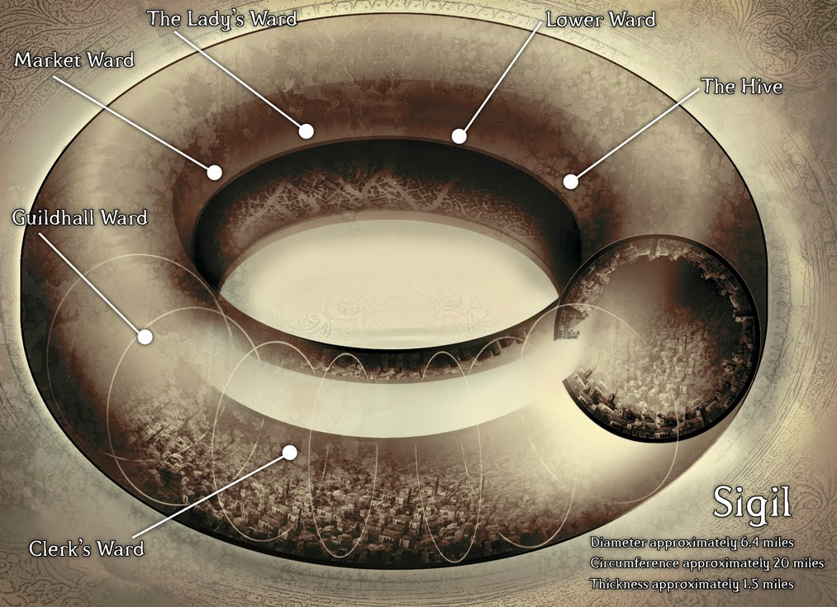

Sigil is the bustling crossroads of the universe, full of portals leading to every known corner of the universe.
Popularion: Approximately 300,000. Representatives of nearly every race and monstrous kind can be found somewhere in the city.
Government and Defense: The only being in Sigil who wields any real authority is the mysterious Lady of Pain, the uncaring guardian and protector of the city. The touch of her gaze causes wounds to spout blood, and her smallest gesture can banish someone or something into an endless maze spawned in a pocket dimension. Her presence is said to prevent deities, demon princes, primordials, and beings of similar power from entering the City of Doors, and the fear of her is sufficient to keep a modicum of order in the streets. Crime is common, but rebellion is unthinkable.

The Wards
Sigil is divided into six regions called wards. The wards aren't an official designation, but everyone knows the difference between one ward and the next, even if locals don't agree on exactly where that difference begins and ends.

Lower Ward
The Lower Ward is perhaps the most symbolic of the Cage as a whole. It gets its name from the large number of portals to the Elemental Chaos (often considered the "lower" part of the multiverse) found there. Forges and smithies throughout the ward draw fiery energy from the Elemental Chaos and release foul-smelling smoke that chokes the air of the ward. Despite the stench, it's hard to avoid the Lower Ward, since most of the city's artisans live and work there, and the place is full of forges, mills, warehouses, and workshops.
Important Venues: Great Foundry (Believers of the Source HQ), Shattered Temple (Athar HQ)

The Lady's Ward
Going counterclockwise around the ring of Sigil, the next stop is The Lady's Ward (and yes, the locals can hear you capitalize all three of those words). The Lady of Pain doesn't live here, but rich citizens and most of Sigil's temples lie within this ward. The Lady's Ward has power, wealth, and majesty, and knows how to show it off.
Important Venues: Armory (Doomguard HQ), City Barracks (Harmonium HQ), City Court (Fraternity of Order HQ), Prison (Mercykiller HQ)

Market Ward:
In the Market Ward, everything is for sale. The wealth of Sigil may be concentrated in The Lady's Ward, but it's spent here, whether on goods, services, information, or reputation. The best place to buy anything is the Grand Bazaar, an immense plaza filled with shops, tents, and stalls offering wares from dozens of planes and strange worlds. Prices can vary wildly, from dirt cheap (for merchants with an unexpected overstock) to many times the normal value (for goods in sudden short supply, due to a faulty portal or a band of planar marauders).
Important Venues: Great Bazaar (Free League HQ)

Guildhall Ward
Many visitors can't tell the difference between the Guildhall Ward and the Market Ward. Even some locals claim that only tradition separates them. Since guilds don't play a particularly significant role in Sigil, one can guess that the name itself owes a lot to ancient tradition. Today, the Guildhall Ward serves as the domain of the middle class of Sigil. Many merchants who hawk their wares in the Market Ward during the day sleep in the Guildhall Ward at night, and many who deal in services (rather than selling finished goods) live in the Guildhall Ward and work there as well. The Guildhall Ward also houses many racial neighborhoods, from the transplanted elf grove of Rethevar to the githyanki community of Gitriban.
Important Venues: Great Gymnasium (Transcendent Order HQ)

Clerk's Ward
The domain of bureaucrats, scribes, sages, and scholars, the Clerk's Ward is a quiet place to get things done without a lot of attention. Some criminal organizations looking to improve their lot move from the Lower Ward or the Hive into the Clerk's Ward, and the fact that the locals here respect each other's privacy encourages activities of an illicit nature. Of course, it wouldn't be Sigil if everything made sense, so the Clerk's Ward is also home to one of the flashiest places in the city- the Civic Festhall. Run by a faction calling itself the Society of Sensation, the Festhall combines the best aspects of a concert hall, museum, and tavern while simultaneously serving as the centerpiece of an artistic neighborhood that brings travelers from across the multiverse. It's the best place in Sigil to see or be seen.
Important Venues: Civic Festhall (Society of Sensation HQ), Hall of Records (Fated HQ), Hall of Speakers (Sign of One HQ)

The Hive
Many locals claim that the Hive isn't a ward so much as it's the lack of a ward. The name for the region between the Lower Ward and Clerk's Ward and for the chaotic, sprawling slum in its center, the Hive teems with all kinds of scum. The lowest of the low dwell in the Hive: those who can't afford (or don't dare) to rub elbows with the more fortunate folks. The Hive is a microcosm of Sigil itself, encompassing everything that is needed in daily life: taverns and inns aplenty, entertainment, and services from pawnbrokers to sellswords. The quality may be questionable, but the prices can't be beat. The Gatehouse Night Market offers nearly everything one could find in the Grand Bazaar (and a few things one couldn't), though it's best not to think too hard about where the goods come from.
Important Venues: The Gatehouse (Bleak Cabal HQ), Hive (Xaositects HQ), Mortuary (Dustmen HQ)

